Dating Agency Project

Hi folks,

What we'll do is reduce the amount of functionality for your group, so I suggest your group produces the following:

CS4065 Project 2018

Allow users to register and describe themselves in a profile. The description should contain traits such as interests, description, seeking, etc.;

Allow users to connect, by sending a notification to other users that they are interested;

Allow users to browse other users (e.g. show all users of a particular type, e.g. all male users);

Allow registered users to perform searches on other users (e.g. list all women over 31 with a particular hobby);

This should give you roughly the same amount of work per person as the other groups.

Regards,

Conor

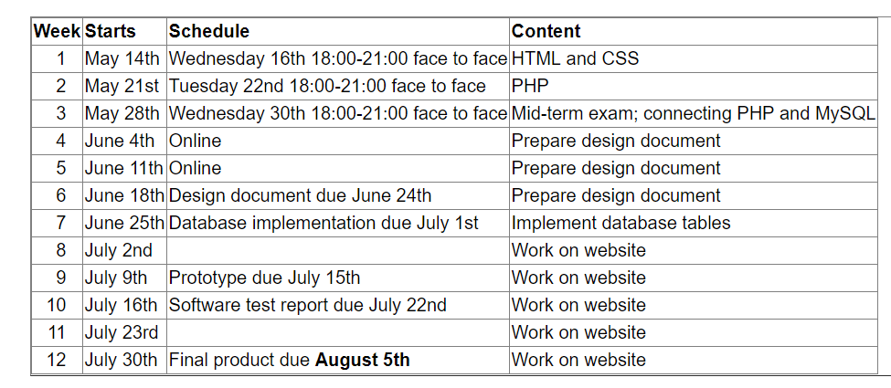

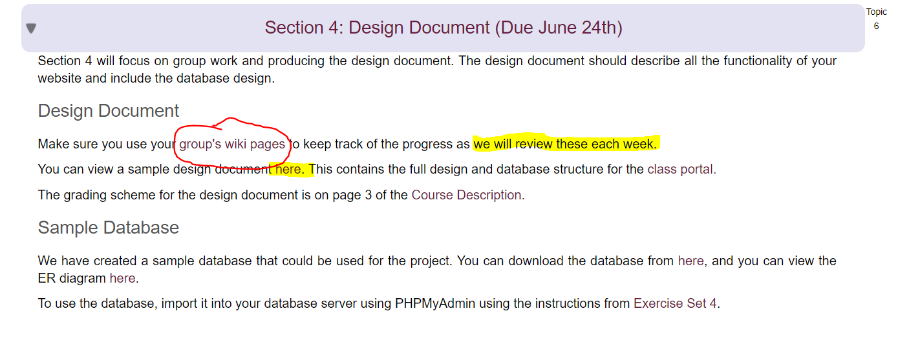

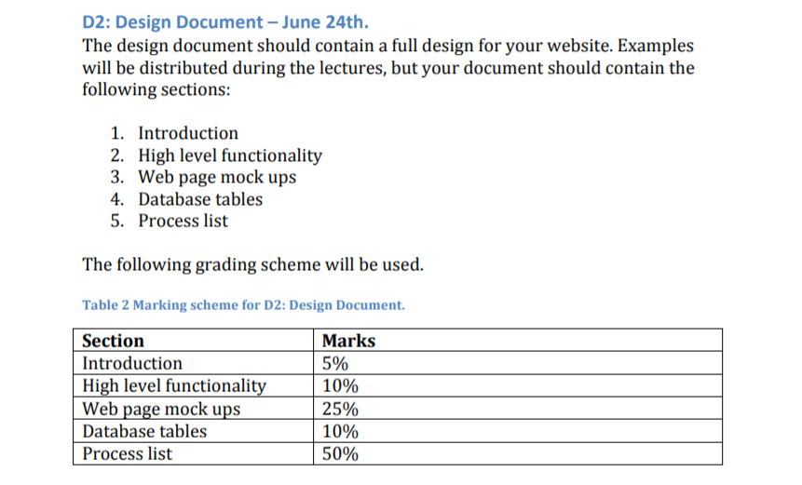

**Design Document**

**Introduction** The Student Submission Website (SSW) is an online portal for collating and maintaining group work for students in UL. It provides a way for students to submit weekly reports about their progress, to keep track of their current share of the grade and for faculty members to examine the reports.

**High Level Functionality** There are two key user types in SSW, students and faculty. Students will be able to log into the system, upload weekly forms, read previous forms and check their current share of the grade. They will also be able to maintain their account by changing their passwords. Faculty will use SSW to view these reports, specifically to be able to view the reports prior to weekly meetings. They will also be able to view past reports and check the breakdown of grades given to each student in the group. In the event that a report is not submitted, the student responsible will be reported to the faculty so that this can be discussed in the meeting.

1. **Allow users to register and describe themselves in a profile. The description should contain traits such as interests, description, seeking, etc.;**
2. **Allow users to connect, by sending a notification to other users that they are interested;**
3. **Allow users to browse other users (e.g. show all users of a particular type, e.g. all male users);**
4. **Allow registered users to perform searches on other users (e.g. list all women over 31 with a particular hobby);**

**User ID**

**Name:**

**Address 1:**

**Address 2:**

**County:**

**Country:**

**Email:**

**Mobile:**

**Male / Female?**

**Your Height?**

**Partner’s ideal height?**

**Your hair color?** (bald, brunette, black, red, blonde, grey, other?)

**Future partner’s hair colour**? (not important, bald, brunette, black, red, blonde, grey, other?)

**Description?** (Brief description of yourself, prospective partners will see this? ....likes to travel, likes socializing, likes quiet nights in front of the fire etc etc)

**Seeking?** (male/female)

**Hobbies / Interests** (i.e. reading, painting, sport, theatre, cinema, great outdoors, socializing etc etc),

**Your Age?** (20-25, 25-30, 30-35, 35-40, 40-45, 45-50, 55-60, 60-65, 65-70, 75-80, 85+)

**Ideal age for a partner?** (20-25, 25-30, 30-35, 35-40, 40-45, 45-50, 55-60, 60-65, 65-70, 75-80, 85+)

**Race? (???)**

**Future partner’s race? (???)**

**Religion? (???)**

**Future partner’s religion? (???)**

**Messaging** (Because we have only 3 in our group, I don’t think we need to do this one?)

**What are you looking for in a relationship?** (Long term / Short term, True love, Marriage, Friendship)

**Have you been married previously?** (yes/no)

**How many previous relationships have you had?**

**Longest term relationship that you have had?**

**What do you want your future partner to be?** (Best friend, soul mate, provider, care taker, arm candy, other?)

**Your education level?** (primary school, junior cert, leaving cert, Third level)

**Partners education level?** (primary school, junior cert, leaving cert, Third level, not important)

**Your annual salary?** (0 – 20K, 20K-40K, 40K-60K, 60K-80K, 80-100K, 100K +)

**Partner’s annual salary?** (Not important, 0 – 20K, 20K-40K, 40K-60K, 60K-80K, 80-100K, 100K +)

**Web Page Mockups**

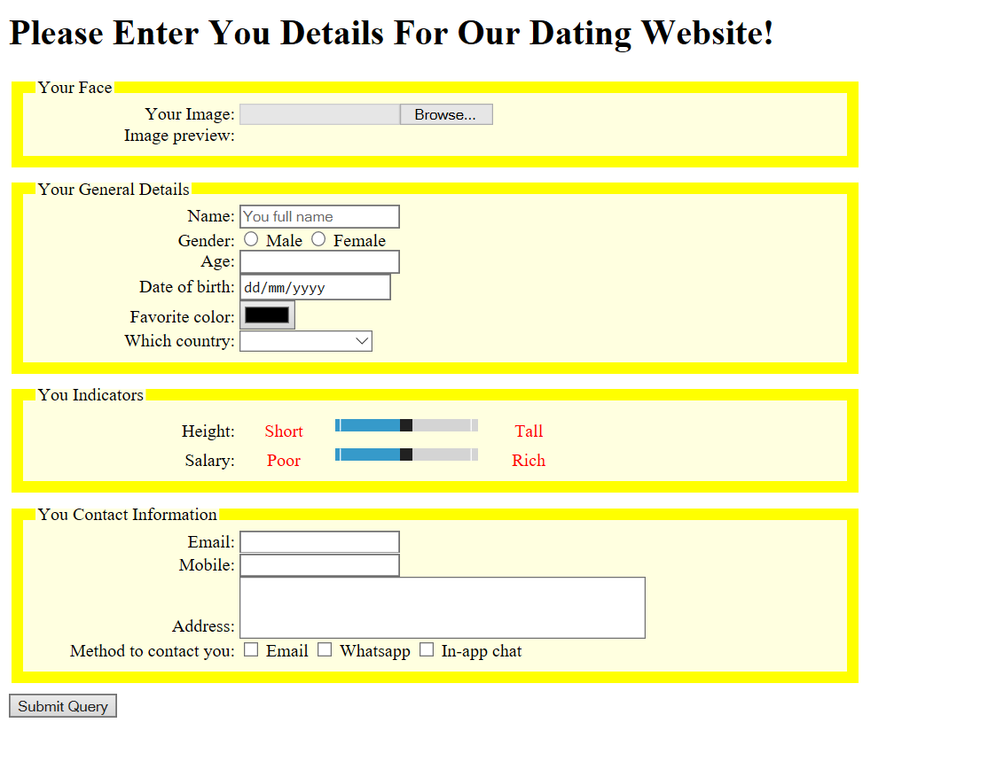

**Database Tables**

**Process List (Flowchart for system /**